Sixth Street and Clipstone Partner to Recapitalise 37-Property UK Multi-Let Industrial Portfolio

London, October 1, 2025 – Sixth Street, a leading global investment firm, and Clipstone Investment Management, the London and South East UK industrial specialist manager, today announced C6 Industrial, a new joint venture to invest in high-quality UK multi-let industrial assets, which will be seeded with the recapitalisation of a 37-asset portfolio owned by Clipstone Industrial REIT plc.

Sixth Street will provide the majority of the equity capital, and Clipstone will continue to manage the portfolio with the JV looking to grow the platform via new acquisitions.

The portfolio totals approximately 1.7 million square feet with assets concentrated around dense urban London and South East UK locations. The properties are located in strong occupational markets, including Enfield, Hanworth, Sutton, Chessington, Welwyn, Bracknell, Reading, Newbury and Stansted Airport. Around 40% of the portfolio is located in the London and M25 area, with the balance across the South East.

“We believe there is a long-term shortage of industrial space in London and the South East, caused by a reduction in supply as industrial space is converted to higher value uses, a shortage of suitable development land and an increase in demand caused, amongst other factors, by London’s high consumer demand for online retailing,” said Toby Dean, CEO of Clipstone. “We are delighted to partner with Sixth Street, who share our conviction on the sector and offer the scale, deep real estate expertise, and flexible capital that will complement our operations, creating significant growth opportunities for both Clipstone and Sixth Street.”
“While the UK’s industrial real estate sector remains supply constrained, multi-let industrial has shown resilience to market downturns due to its mature and diversified tenant base,” said Giulio Passanisi, Partner and Head of European Real Estate at Sixth Street. “The breadth of Clipstone’s existing portfolio in London and South East UK and associated market knowledge is a key value add. Toby and the Clipstone team have a strong reputation in the UK industrial market and we look forward to working together as we grow this platform.”

Sixth Street was advised by ACRE, Linklaters, EY and Jones Hargreaves. Clipstone was advised by Newmark, Hogan Lovells, Fladgate and Russell-Cooke.

About Sixth Street
Sixth Street is a global investment firm with over $115 billion in assets under management and committed capital. The firm uses its long-term flexible capital, data-enabled capabilities, and One Team culture to develop themes and offer solutions to companies across all stages of growth. Founded in 2009, Sixth Street has more than 700 team members including over 290 investment professionals around the world. For more information, and additional disclosures, visit www.sixthstreet.com, and follow Sixth Street on LinkedIn.

About Clipstone
Clipstone Investment Management Limited is a real estate fund management firm specialising in UK industrial property. Formed in 2008, Clipstone manages a number of funds and segregated accounts, including for private equity investors, Charities, Endowment Funds and private capital. Clipstone is one of the top performing real estate managers in the UK, with the REIT ranked fifth (out of 166 portfolios) in the MSCI UK Quarterly Property Index (as of 30 June 2025). Across its various mandates Clipstone has approximately £800m of long term capital under management. Further details are available at: www.clipstone.co.uk.

Media Contacts:
Sixth Street: media@sixthstreet.com

CIipstone: louise.dolan@camarco.co.uk / ed.gascoigne-pees@camarco.co.uk

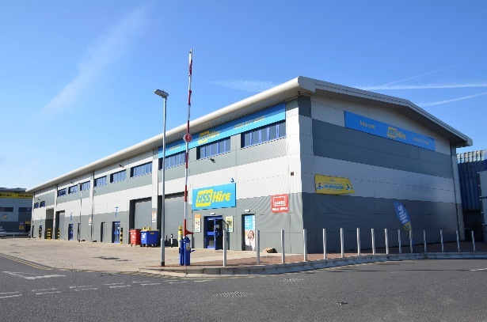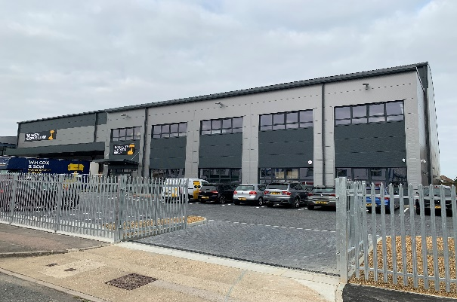

Hanworth Trade Park, Hampton Road West, Hanworth, TW13 6DH
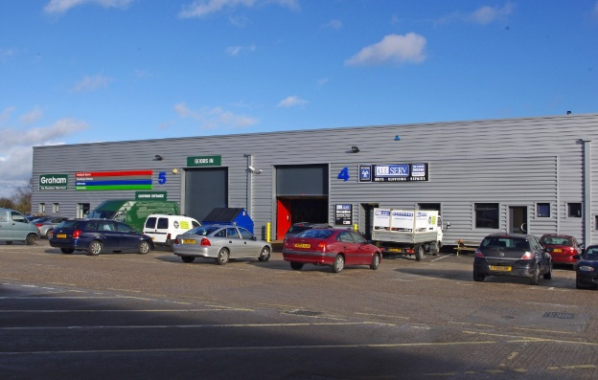

Oakcroft Business Centre, Oakcroft Road, Chessington, KT9 1RH
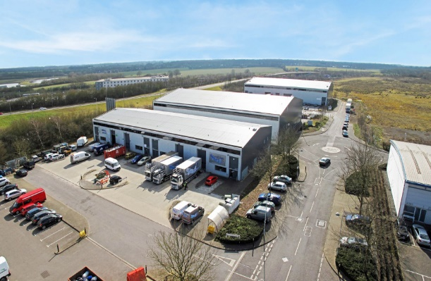

Taylors End Industrial Estate, Stansted,
Essex, CM24 1RL

Bilton Industrial Estate, Lovelace Road,
Bracknell, RG12 8YT

